**HTML Assertion in JMeter:**

Right click on test-add thread-right click add HTTP request.

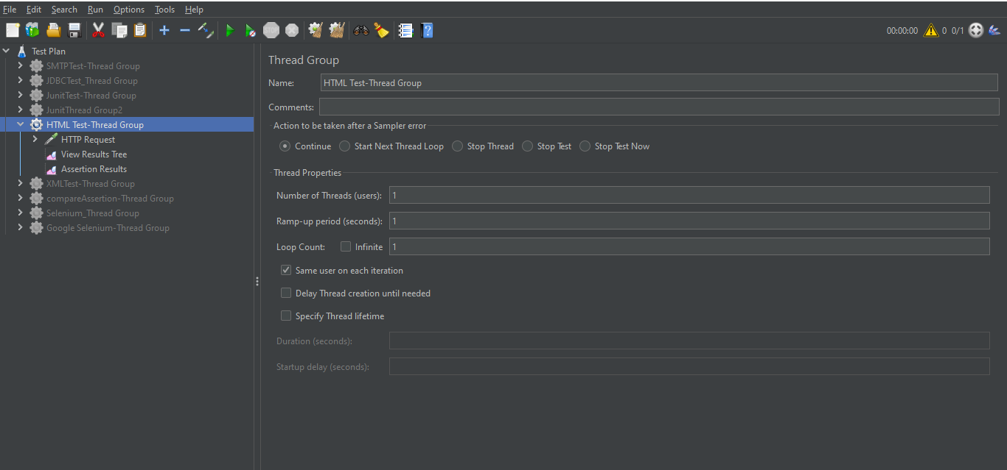

In HTTP request add the server to test.

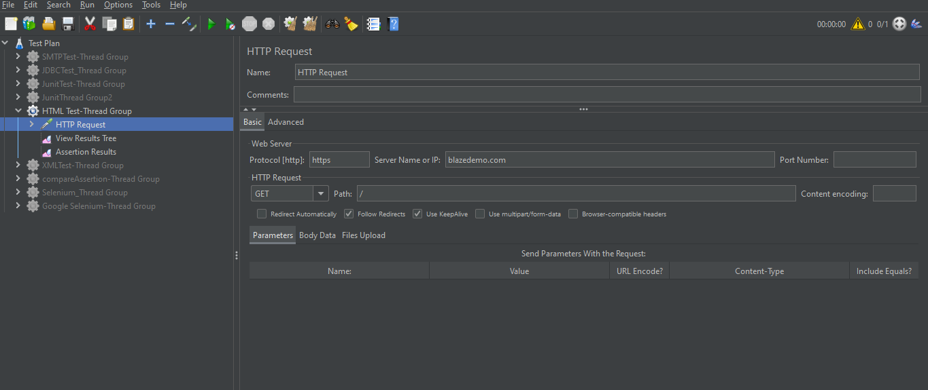

HTTP request right click-add HTML assertion ,First we created the folder for warnings, browse the path.

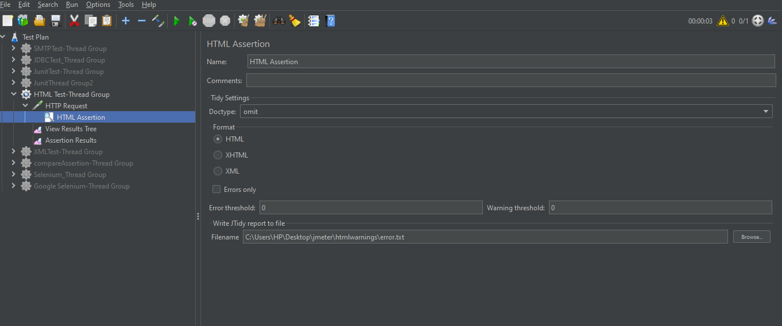

As below we can see its failed because there is no error in page.

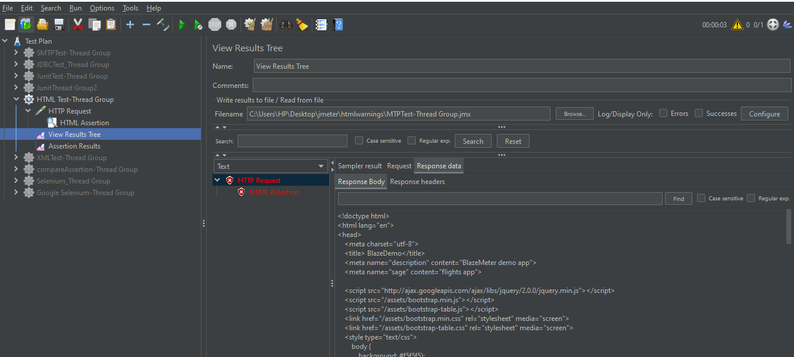

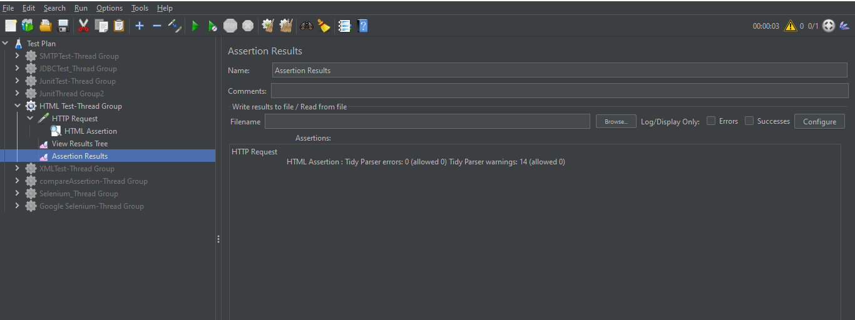

As we can see below the warnings are stored in that folder.

